Nandini Ramakrishnan

Ramakrishnan_Nandini_Proj2

1. Give a brief "pitch" of a few sentences that describes the users and tasks your system will support.

The domain I chose was telemedicine and telehealth, meaning that the users of this system will be doctors and their patients. The system I will be working on will be designed specifically for general medicine and general health checkups. The system will help make remote doctor’s appointments much more effective, promoting the accuracy of patient diagnoses.

For this particular system, there are two main users: the doctors, and the patients. The system will be monitoring the patients (and certain audio cues from them), and reporting that data back to the doctors, so that the virtual appointment is better able to simulate an in-person environment. When people meet in person, they are better able to gauge and respond to audio cues the other person gives off.

This system can be specifically tailored to general appointments, so that the system will be designed to keep track of certain things, instead of a huge spectrum of sounds. This way, the system will be more accurate, as it will be designed for a smaller, specific set of sounds rather than a large variety.

The main task the system would support is monitoring the patient and reporting the data back to the doctor. Data that can be monitored includes breathing patterns, essential tremors, heart rate, blood pressure, voice signals and indicators, hesitance/eagerness to answer questions, as well as other patient details. This system will be tasked with constantly monitoring these values in patients throughout the duration of the appointments. Additionally, when anomalies or signs not considered “normal” are detected, the system will report the information to the doctor.

1. Provide a user persona that represents the type of person you will be designing for.

This system will be designed for doctors and their patients, specifically for doctors and patients going for general checkups.

Persona of the Doctor(s):

* Photo
  + 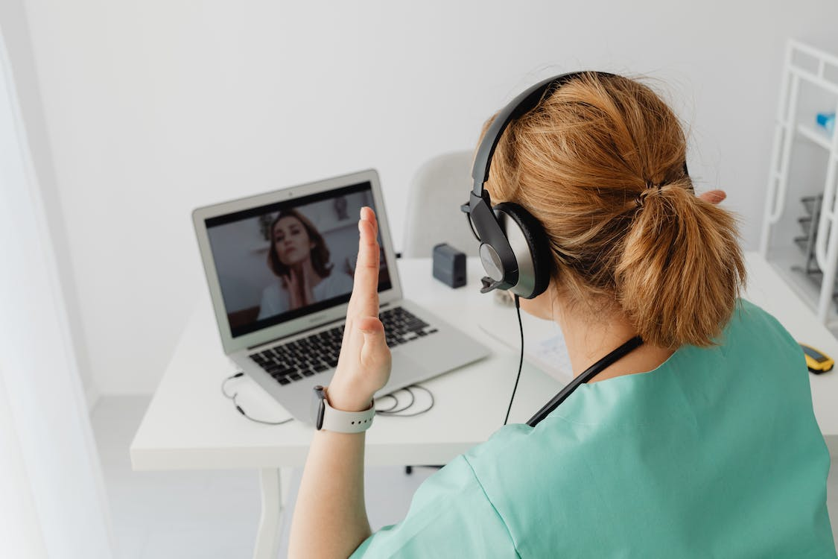
  + This is a photo of a patient and a doctor interacting via remote appointment. This photo shows the two people interacting by video. They currently speak to each other and use visual cues to communicate.
  + Photo Source: <https://www.pexels.com/photo/doctor-communicating-with-a-patient-via-internet-7195090/>
* Name
  + The name for the doctor persona would be Dr. ___ [insert name here]. There is no one name that suits this persona.
* Description
  + The persona for a doctor will have a background that consists of the proper education necessary to become a general practitioner. Additionally, this person should currently work at a hospital/clinic that offers remote appointments to patients. Their current desire is to best support and provide service to all their patients, as well as reach a wider audience with the remote platform. Their primary motivation for using this service/tool is to serve their patients and simulate an in-person appointment better with audio cues from the patient. Some of their goals include maximizing patient satisfaction, being able to monitor vials through audio the entire meeting, and making the meeting seem as personal as possible. The doctor should be located in their office or hospital, with good connection to wifi or network, and have a high experience level for their position.
* User Quote
  + “I want a better audio patient-monitoring service so that I can better simulate an in-person meeting while reaching a wider audience.”
* Problems
  + Some personal struggles that the doctor persona faces are not being able to fully gauge a patient’s condition in a remote environment (specifically for general health checkups), and not being able to have the patient feel like they are getting the best care possible, even remotely.
* Narrative
  + Dr. ___ is a general practitioner at ___ clinic/hospital, and has been practicing for 5-30 years. They are experienced with handling patients, as well as using technology to communicate remotely. They love helping patients, which is why they are excited to be able to use the new system. They want to use it to be able to better serve and diagnose their patients remotely.
* Goals
  + Dr. ___ would like to be able to better simulate an in-person appointment, diagnose their patients, and increase patient satisfaction.
* Needs
  + This product/service/system needs to be able to detect patient breathing patterns, essential tremors, heart rate, blood pressure, voice signals and indicators, hesitance/eagerness to answer questions, as well as other patient details. The system needs to be constantly monitoring these values in patients, and will not need to be started or stopped. When the system detects that something is not “normal,” then it needs to notify the doctor. (same for both doctor and patient personas)
* Frustrations
  + Some frustrations that the doctor persona experiences are not being able to fully examine the patient due to constraints put on by the remote platform, not being able to maximize patient satisfaction, and not being able to constantly hear and monitor basic patient conditions due to lack of proper connection through a remote platform.
* Key Differentiators
  + The key differentiator of this persona is that they are a doctor, and are on the monitoring side of the system. They do not actively use the system, just make note of what the system outputs and tells them.

Persona of the Patient(s):

* Photo
  + 
  + This is a photo of a patient and a doctor interacting via remote appointment. This photo shows the two people interacting by video. They currently speak to each other and use visual cues to communicate. This photo depicts both the doctor and the patient communicating using a remote platform.
  + Photo Source: <https://www.pexels.com/photo/doctor-communicating-with-a-patient-via-internet-7195090/>
* Name
  + The name for the patient persona would be Mx. ___ [insert name here]. There is no one name that suits this persona, as the system should serve every patient coming in for a general health checkup.
* Description
  + The persona of the patient(s) should generally be of someone with an unspecified background. They just have to feel the need to come in for a general health checkup, whether that means they suddenly aren’t feeling well, or they think they haven’t gone to one in a while, so it’s time to get checked out again. The patient should be of ages 18-40 (just to narrow down the population and have the system tailored to specific vital signs for that age group), and should be open to getting checked remotely. Their current desire for this system is to get the best treatment possible (whether that be remotely or in person), and help other patients do so as well with their feedback and the success of the system. Their primary motivation for using this service/system is for convenience, to get the best care possible from their own residence, rather than having to travel far for their appointment. Some of their goals include not having to travel far for their appointment, getting properly diagnosed, and getting the feel and level of care of an in-person appointment while being remote. The patient should be located in a place that’s convenient for them to be at, while also having a good internet connection. There is no experience level for the patient, just for them to be between the ages of 18-40, so that the system can be calibrated to look for signs for people in that age bracket.
* User Quote
  + “I want an audio-monitoring service/product/system for me so that I can receive the same level of treatment and care that I would receive at an in-person appointment while being remote.”
* Problems
  + Some problems that the patient personas face are not receiving the proper care from a remote system, not receiving the best treatment possible, not being able to fully interact with their doctors, and not being satisfied with the level of doctor-patient care that they get.
* Narrative
  + Patient ___ is a person between the ages of 18 and 40 that is looking to get a general health checkup remotely. They have experience with in-person health checkups, good care, bad care, and using remote communication tools. They are open to trying the new remote system, and would love to have it work. They want to use it to be able to get the same care they would get in person, without having to travel far to get it.
* Goals
  + Patient ___ would like to be able to receive proper care remotely, maximize doctor-patient interaction, and receive a proper diagnosis for their problems at a general health checkup.
* Needs
  + This product/service/system needs to be able to detect patient breathing patterns, essential tremors, heart rate, blood pressure, voice signals and indicators, hesitance/eagerness to answer questions, as well as other patient details. The system needs to be constantly monitoring these values in patients, and will not need to be started or stopped. When the system detects that something is not “normal,” then it needs to notify the doctor. (same for both doctor and patient personas)
* Frustrations
  + Some frustrations that the patient persona experiences are not getting the same feel and level of care as an in-person appointment, not receiving the proper treatment due to a lack of meeting in person, and feeling the lack of connection between doctor and patient (not feeling like the doctor cares enough to give the proper diagnosis/care).
* Key Differentiators
  + The key differentiator of this persona is that they are the patient, and are on the side of the system that is being monitored. The patients don’t see the output/results of the system, and are just the people getting measured. They don’t need to periodically start or stop the system, as it is constantly monitoring the patients and reporting back to the doctor.

1. Describe in three scenarios for the tasks that your system will support. These scenarios should convey what data will be conveyed to the user via audio throughout and how the user ideally will perceive and interpret it and how that will differ as the data changes. Also describe inputs and input modalities the user will have to communicate back to the system.

Three scenarios for the tasks that my system will support are checking whether the patient is breathing normally, making sure the patient does not show any signs of essential tremors or stress, and measuring the patient’s responsiveness to the doctor to improve patient satisfaction of the appointment.

The first scenario that the system will support is constantly checking whether the patient is breathing normally. This system will be used by doctors to monitor their patients remotely. The data that will be conveyed to the user can be in the form of breathing sounds, breath rate, and any unusual breathing patterns or pauses. The doctor can use this data throughout the appointment to check on the patient. The user (the doctor persona) will ideally use it to diagnose any respiratory conditions, monitor patient progress (if they are on medications or a recovery plan), and diagnose any possible sleep disorders. If the data all looks normal, the doctor will proceed as normal and will confirm that the patient’s health is sound. Otherwise, if the data does not look good, the doctor can take certain steps depending on the situation. For example, the doctor can help the patient through exercises improving the patient’s breathing patterns, educate the patient about what to look out for in their breathing, and in a much worse situation, the doctor can call them in for an in-person appointment to receive medication and treatment. Some possible inputs and input modalities that the doctor can use to communicate back to the system are verbal communication (for a voice-controlled system) and text-based inputs for the system to know that the doctor has seen the signs and will respond appropriately.

The second scenario that the system will support is making sure the patient does not show any signs of essential tremors or excessive stress. This system will be used by doctors to monitor their patients remotely. Data that will be conveyed to the doctor via audio can be tremor sounds, voice tremors, and speech patterns. The doctor will ideally perceive and interpret the data to diagnose stress disorders and prescribe the proper medications or treatment plans depending on the situation. If the data is normal, the system will not alert the doctor, but if the data shows potentially concerning signs, the doctor will be alerted and can respond accordingly. For instance, if a patient’s hand starts violently shaking, the doctor will be alerted via the system, and can start taking steps to calm the patient down, find the cause of the stress, and diagnose the patient based on that. Some inputs and input modalities the user will have to communicate back to the system are numeric inputs or buttons that the doctor can use to let the system know that the issue has been taken care of.

Finally, a third scenario this system can support is measuring the patient’s responsiveness to the doctor to improve patient satisfaction of the appointment. This system will be used by doctors to monitor their patients remotely. The data will be conveyed to the user in the form of response time, the tone of the patients’ voices, and other voice indicators of a patient’s happiness and satisfaction. The user (the doctor) will ideally perceive and interpret this data by looking at the system’s outputs regarding the measured data. For example, the doctor will be looking at the system to check the patient’s mental condition/happiness. As the data changes, the doctor can take steps to make the data more favorable. If there is a certain behavior that the doctor does that makes the patient happier, the doctor will continue doing that. The purpose of this data is to help increase patient satisfaction by letting the doctor know how the patient feels throughout the appointment. If the patient isn’t very satisfied, the doctor can be more interactive with the patient and ask them how to help. Lastly, some inputs and input modalities the user will have to communicate back to the system can be selection from options, annotations, and voice commands from the doctor to the system to mark certain alerts as “resolved” or “in progress.” This will let the system know that any current issues that the patient is facing are being attended to, and the doctor is aware of such issues.